**Revenge is Much Sweeter**

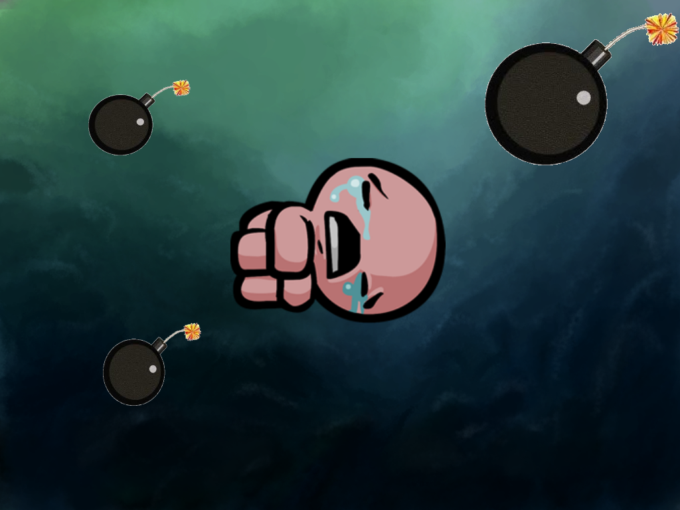

**Characters:**

Player –

**Lucifer:**

Play as Lucifer the Fallen One, as you fight your way through the various hordes of heavenly angels and arch-angels, on your ruthless vendetta against those that betrayed you. Single character versus the rest, use powerful and hellish attacks to annihilate your foes and redeem yourself.

**Dracula:**

Control Dracula, re-risen by ancient magic’s, scorned by society, your heart has been tainted by the cruelty and misunderstanding of man, and you seek to show the humans the error of their transgressions against you. Blood based attacks, summon and support your own minions.

NPC –

A collection of the enemies that will feature in the game.

**Angles:**

A varies random slew of enemy angles of three different skill type.

* Nephilim – Half Human, Half Angel, basic unit which deals moderate melee damage.
* Cherubs – Flying units, which follow the map pattern, but fire projectiles over obstacles.
* The Arch Allegiance – Angels of the highest order, very strong, your former brothers.

**Humans:**

Standard humans of two types.

* Mob – Normal human, deals moderate damage.
* Knight – Deals greater damage, faster unit, kills minions very easily.
* Vampire Hunter – Lethal Damage unit, avoid.

**Moving Rules:**

Move unit using arrow control keys, space plants general bombs, WASD keys control various abilities of the player, Lucifer drops Light and Hellfire bombs, and Dracula drops minions; zombies, bats, wraiths and dogs.

**Scoring Rules:**

Gain 5 points for killing a normal unit, 10 for second tier units and 50 for boss tier units. Multipliers pickups available throughout each level. Killing multiple units in a chain will result in a combo multiplier. Certain scores attained on each level will result in additional consumable items, such as summoned minions or power moves.

**Art Assets:**

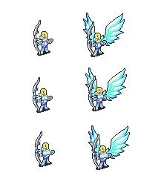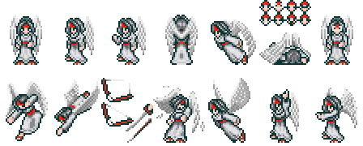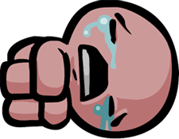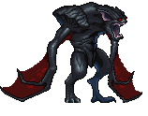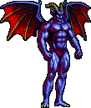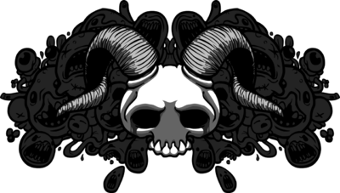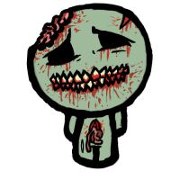

**Sound Assets:**

General Death Sounds, firing of units and summoning Minions. Small voice samplings and dialogue scenes.

**Screen Shots of Similar Games:**

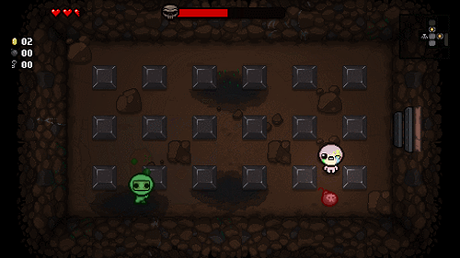

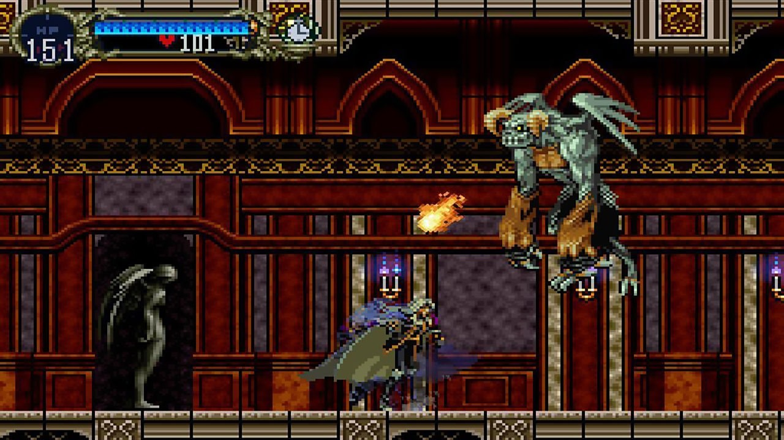

**Tutorial progression**

Player will learn how to move the unit and setting bomb, and show every items’ effect.

Easy mode: player can setting five strong bomb start.

Normal mode: player can setting three normal bomb at start.

Hard mode: player can setting one normal bomb at start.